Mid-Term Examination

**Due 11 February 2013**

Name: ID No.:

**Part I. Short Answers**: Answer the following questions by completing the statement or providing a brief sentence that succinctly provides the information requested. 20 points

|  |
| --- |
| 1. What three threats to human health and survival have been present since the beginning of human evolution? 2 pts. |
|  |

2. A relatively easy away to differentiate rodents from other mammals is by the: 2 pts

|  |
| --- |
|  |

3. Provide three reasons why rats (especially the black rat) are such an ideal vector for spreading disease to man? 2 pts

|  |
| --- |
|  |

4. In what respect does the brown rat's preferred nest differ from that of the black rat? 2 pts

|  |
| --- |
|  |

5. What is the major difference between mouse and rat feeding styles? 2 pts

|  |
| --- |
|  |

6. List five reasons why mice are potentially more destructive than rats: 5 pts

|  |
| --- |
|  |

7. List five ways humans can detect rodent presence: 5 pts

|  |
| --- |
|  |

**Part II. Essay Question**: Answer each of the following four questions. Use the space provided and keep your answers brief; however, provide enough information to demonstrate your understand­ing of the principles and issues involved. You may use the back of the page if you need more space. As always, the use of complete, grammatically correct sentences is socially acceptable. (And, while the use of proper grammar is highly encouraged, *legible writing is required*.) (20 points each)

1. Figure SA-1. Depicts the geographic distribution of deaths from vector-borne diseases around the world. What is striking about this distribution pattern? Because deaths are reported by country, why should we not expect that the deaths are evenly distributed throughout the country? Who (what populations) are most at risk? Explain why.

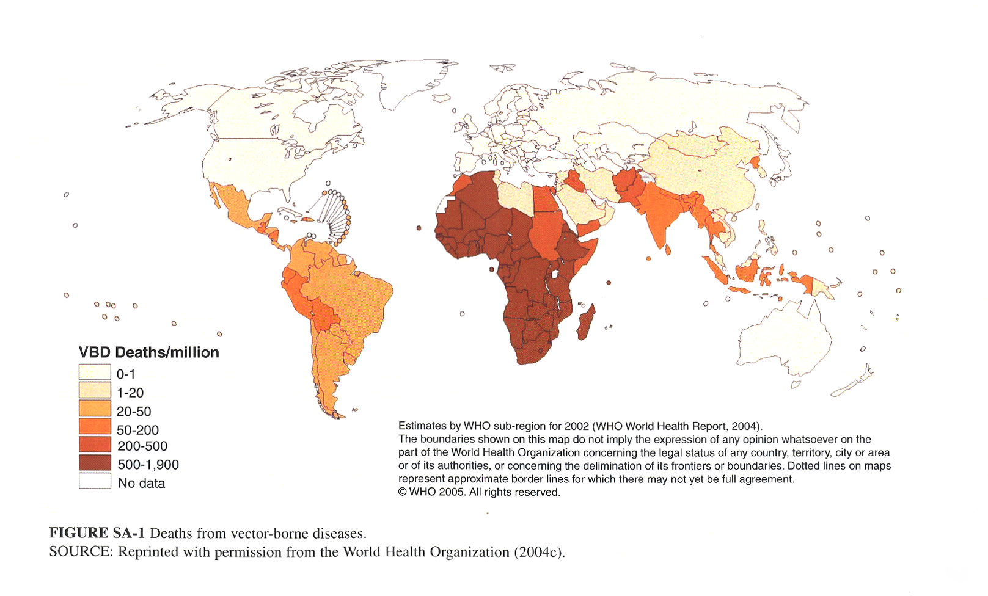

2. Factors of emergence – In class we discussed six sets of factors that explain the rise of emerging and reemerging infectious diseases in past several decades.. Describe four of these factors, explaining how/why they contribute to the increase in infectious diseases world-wide.

3. The “Black Death” is thought to have killed up to one-third of the population of Europe in the mid-  
14th century. What was the “Black Death”? Why was the Black Death so destructive in Europe? How is it spread? And, what has changed in the intervening years to make such outbreaks either more or less likely to occur today than in 1347? Finally, if such an outbreak is unlikely, why should we be concerned about this Medieval disease today? Support your answer.

4. On April 29, a 29-year-old woman residing in Snohomish county, reported fever, myalgia, decreased appetite, headache, vomiting, back pain, and chills, and a seasonal, allergy-related cough. When examined at a local ED, her temperature was 101.5 F (38.6 C). A viral infection was diagnosed, and she was sent home. On May 1, she went to a different facility with worsening symptoms, including ear pain, nausea, and a dry cough that had worsened. A CBC showed thrombocytopenia, and she was transferred to the first facility's ED. Blood tests revealed a platelet count of 66,000/mm3; WBC, 4700/mm3; and Hct, 47.0% (normal: 33%-43%). The patient was immediately transferred to a regional medical facility. Chest radiographs were clear on the evening of admission and the following morning, but by the evening of May 2 her cough had continued to worsen and bilateral infiltrates were observed on her radiograph. On May 3, peak lactate was 5.5 mmol/L (normal: 0.5-2.0 mmol/L), and the cardiac index was 1.9. The patient improved with dobutamine and supplemental oxygen and was discharged in stable condition on May 9.

What disease condition did this patient have? As the sanitarian in the Snohomish Health District assigned to perform the follow up investigation, explain what steps you would take, what you would be looking for, and why?